Common Activation Functions and Their Formulas
Here are the formulas for commonly used activation functions in neural networks:
- Sigmoid Function
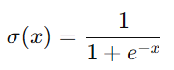
​Output range: (0,1)
  - Used in LSTMs for gates.
- Tanh (Hyperbolic Tangent) Function
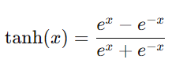
​Output range: (−1,1)
  - Used in LSTMs for candidate cell state.
- ReLU (Rectified Linear Unit)
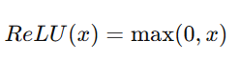
  - Output range: (0,∞)
  - Used in deep networks to prevent vanishing gradients.
- Softmax Function (for multi-class classification)
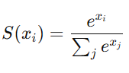
​​
  - Converts logits into probability distributions.

